Our Dentists
DonaldMcNicol (M) BDS dipMFGDP MGDS RCPS(Glas) FCGDent FDS RCPS(Glas) FDS RCS Ed FRSH GDC no 61655 (1986)
GDC no 61655
Gillian M Lennox (F) BDS FCGDent dipMFGDP GDC no72947 (1997)
Natalie Ho (F) BDS
GDC no 317480 (2024)
Sarah Frobisher(F) BDS
GDC no 290316 (2020)
Margaret Walker (F) CEB Cert in Dental Hygiene GDC no 3180 (1986)

Opening Hours
Stenhousemuir
Monday 8.30am – 6.00pm
Tuesday 8.30am – 6.00pm
Wednesday 8.30am – 6.00pm
Thursday 8.30am – 6.00.pm
Friday 8.30am – 5.30pm

Address 374 Main Street
Stenhousemuir
FK5 3JR
Telephone 01324 552892

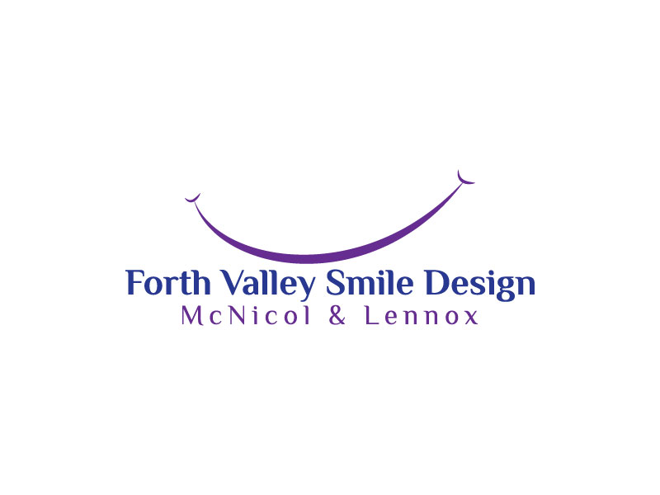 Patient Information Leaflet

www.forthvalleysmiledesign.co.uk
reception@forthvalleysmiledesign.co.uk

For more details of dental services within Forth Valley Health Board please visit www.nhsforthvalley.com

About Us
Welcome to the practice. Our aim is to provide high quality care for all the family with an understanding and caring approach.
Dental Care
We offer NHS treatment to all registered patients, however not all forms of treatment (especially cosmetic treatments) are available on the NHS. We offer a comprehensive range of private treatments including tooth whitening, tooth coloured fillings and crowns and The Inman Aligner.
We also offer a range of non-surgical facial aesthetics treatments including wrinkle reduction and lip enhancements.
Your dentist will be able to explain what NHS or private treatment options are available to you. Our reception team can also discuss your NHS or private options
Medical History
You will be required to fill out a confidential medical history form at your examination appointment. This will be updated at subsequent examination appointments. It is vitally important that we have up to date medical information about you in order that we can safely provide your care.
New Patients
Both practices are currently registering new NHS patients. After a full examination you will sign a registration form. You will then be a registered NHS patient with the practice. If you fail to attend an initial examination appointment, we reserve the right not to reappoint you.
Cancelled/Missed Appointments
Please give a minimum of 24 hours’ notice if you need to cancel your appointment. If you fail to attend an appointment or cancel with less than 24hours notice, you may be charged a fee. We reserve the right to deregister patients who frequently fail to attend their appointments.
Payments
The maximum patient charge per course of treatment on the NHS is currently £384. NHS fees are set by the Scottish Government. You may be entitled to help with NHS treatment costs. Please ask the reception team for details, visit www.nhsinform.scot or phone NHS inform on 0800 22 44 88. For fee paying patients we require payment at each visit. Where lab services are provided at least 1/3 of the treatment cost must be paid by the impression stage. We accept cash, Visa, Mastercard, Maestro, ApplePay, Google Pay and Samsung Pay
Accessibility
Both practices have ground floor access that can accommodate wheelchair users. The Falkirk practice has a dedicated wheel chair access ramp and wheel chair accessible toilet.
Emergencies
For emergencies during working hours please contact the practice and we will give you advice and arrange to see you as soon as is practicable. We will endeavour to see patients under 16 on the same day where possible.
Out with normal working hours if you have a genuine dental emergency please phone NHS 24 on 111.
Interpreting services
English is the only language spoken in the practice. If you require the use of an interpreter please phone 01324 590886
Complaints
If you feel you have cause for complaint, please ask to speak to or write to the practice manager, Rhona Dick

